/* A crime has taken place and the detective needs your help. The detective gave you the crime scene report, but you somehow lost it. You vaguely remember that the crime was a ​murder​ that occurred sometime on ​Jan.15, 2018​ and that it took place in ​SQL City​. Start by retrieving the corresponding crime scene report from the police department’s database */

Select * FROM crime_Scene_report

Where City='SQL City' AND date=20180115 AND type='murder'

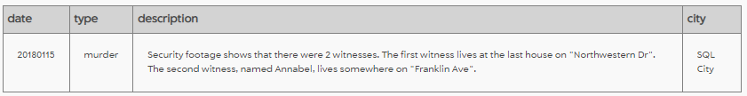

Security footage shows that there were 2 witnesses. The first witness lives at the last house on "Northwestern Dr". The second witness, named Annabel, lives somewhere on "Franklin Ave".

Select Max(address_number) FROM person

Where address_street_name='Northwestern Dr'

--last house on "Northwestern Dr" is 4919

Select * FROM person

Where address_number=4919

-- Morty Schapiro is our first witness

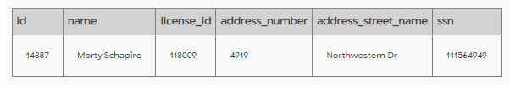

--Annabel Miller is our Second witness

Select * FROM person

Where name LIKE '%Annabel%' AND address_street_name='Franklin Ave'

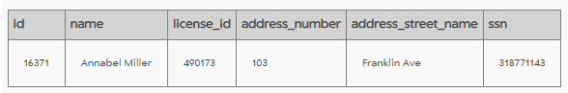

-- what did both witnesses said in interview

Select * FROM interview

Where person_id=16371 OR person_id=14887

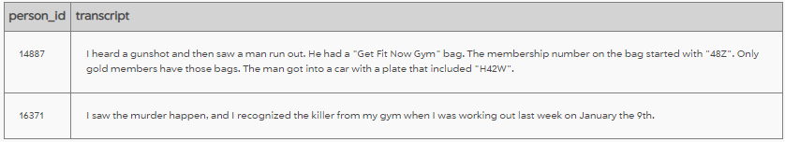

--Checking if both are members of get fit club, Only Anna is member of club.

Select * FROM get_fit_now_member

Where name ='Annabel Miller' OR name ='Morty Schapiro'

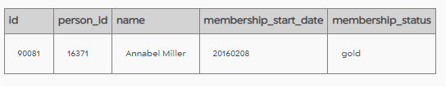

--Checking when she last went to fitness club

Select * FROM get_fit_now_check_in

Where membership_id =90081

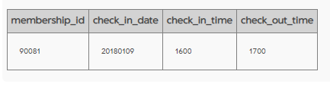

--Checking for people who worked out on same day as Anna and had gold membership status, , there were 5 more people in addition to Anna.

Select * FROM get_fit_now_member M

Join get_fit_now_check_in I ON M.id=I.membership_id

where check_in_date=20180109 and membership_status='gold'

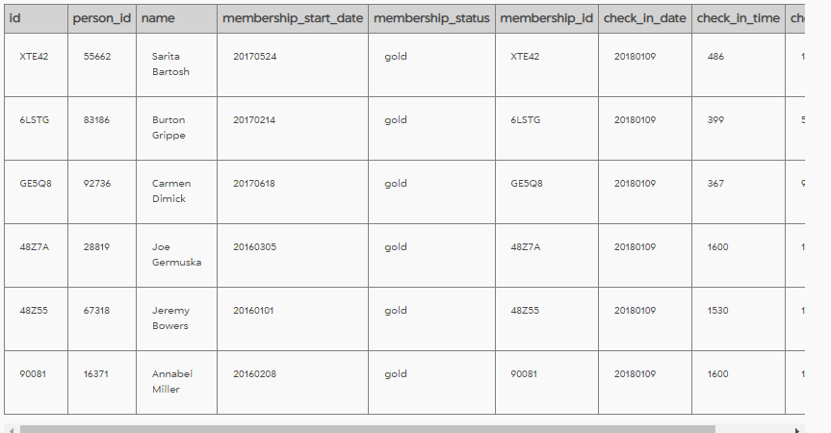

--Further refining results, to find people who worked out at almost same time Anna worked out. there were 2 more people.On further inspection of data both ID start with 48Z.

Select *

From

(Select * FROM get_fit_now_member M

Join get_fit_now_check_in I ON M.id=I.membership_id

where check_in_date=20180109 and membership_status='gold')

Where (Check_in_time Between 1500 AND 1700) AND (Check_out_time Between 1600 AND 1800)

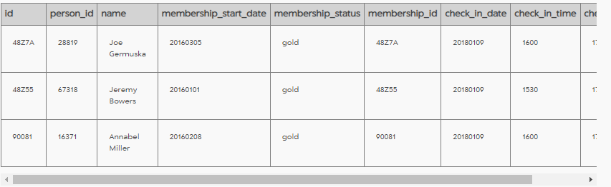

--Pulled data for both from persons table

Select *

From person

where id=28819 OR id=67318

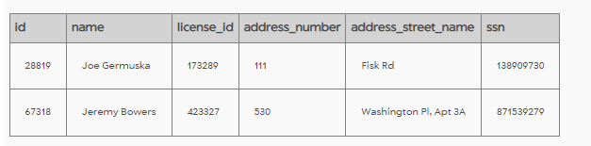

-- Trying to pull license plate number, only One has car

Select *

From drivers_license

where id=173289 OR id=423327

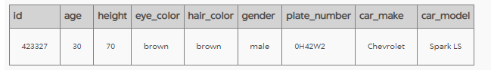

--he is killer his number plate matches one told by witness

Select *

From person

where license_id=423327

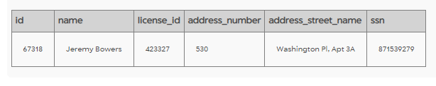

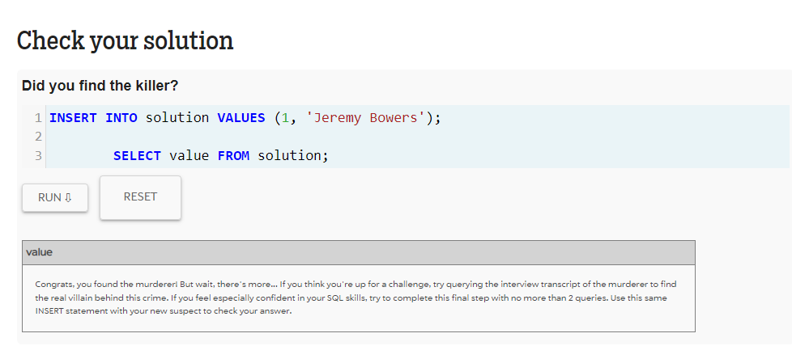

-- read killers interview script

Select *

From interview

where person_id=67318

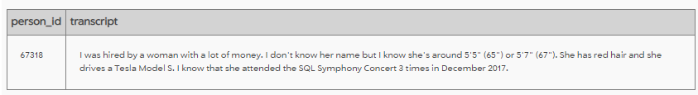

-- Pulling results for red hair females who attended symphony event 3 times in 2017,killer is Miranda Priestly

SELECT *

FROM

drivers_license

JOIN person ON person.license_id=drivers_license.id

JOIN facebook_event_checkin ON person.id=facebook_event_checkin.person_id

Where

(height BETWEEN 65 AND 67) AND (gender='female')AND(hair_color='red')AND(car_make='Tesla')

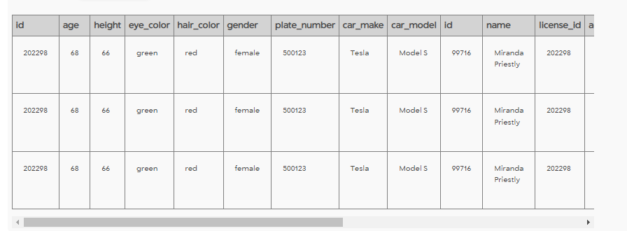

-- Checking results

SELECT *

FROM

drivers_license

JOIN person ON person.license_id=drivers_license.id

Where

(height BETWEEN 65 AND 67) AND (gender='female')AND(hair_color='red')AND(car_make='Tesla')

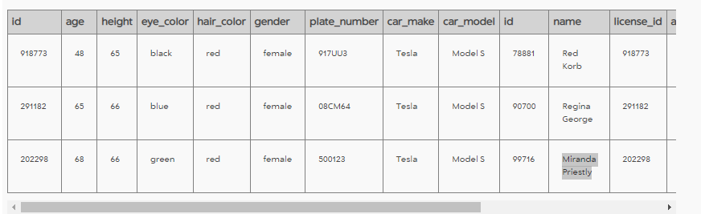

--- Checking how many times Miranda Priestly attended SQL concert it checks out.

Select *, Count(person_id) as Total

FROM facebook_event_checkin

Where

(event_name LIKE '%SQL Symphony Concert%') AND (date BETWEEN 20170101 AND 20171231)

AND(person_id=99716)

Group BY person_id

Having Total=3

